MySQL BETWEEN

## **Introduction to MySQL BETWEEN Operator**

The BETWEEN operator is a logical operator that specifies whether a value is in a range or not. Here’s the syntax of the BETWEEN operator:

value BETWEEN low AND high;

The BETWEEN operator returns 1 if:

value >= low AND value <= high

Otherwise, it returns 0.

If the value, low, or high is NULL, the BETWEEN operator returns NULL .

For example, the following statement returns 1 because 15 is between 10 and 20:

SELECT 15 BETWEEN 10 AND 20;

The following example returns 0 because 15 is not between 20 and 30:

SELECT 15 BETWEEN 20 AND 30;

Note that MySQL treats 1 as true and 0 as false.

### **NOT BETWEEN**

To negate the BETWEEN operator, you use the NOT operator:

value NOT BETWEEN low AND high

The NOT BETWEEN operator returns 1 if:

value < low OR value > high

Otherwise, it returns 0.

For example, the following statement returns 0 because 15 is not between 10 and 20 is not true:

SELECT 15 NOT BETWEEN 10 AND 20;

In practice, you’ll use the BETWEEN operator in the WHERE clause of the SELECT, UPDATE, and DELETE statements.

## **MySQL BETWEEN operator examples**

Let’s practice with some examples of using the BETWEEN operator.

### **1) Using MySQL BETWEEN with number examples**

See the following products table in the sample database:

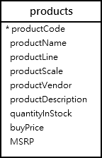

The following example uses the BETWEEN operator to find products whose buy prices between 90 and 100:

SELECT

productCode,

productName,

buyPrice

FROM

products

WHERE

buyPrice BETWEEN 90 AND 100;

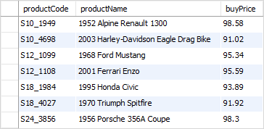

This query uses the greater than or equal (>=) and less than or equal ( <= ) operators instead of the BETWEEN operator to get the same result:

SELECT

productCode,

productName,

buyPrice

FROM

products

WHERE

buyPrice >= 90 AND buyPrice <= 100;

To find the products whose buy prices are not between $20 and $100, you use the NOT BETWEEN operator as follows:

SELECT

productCode,

productName,

buyPrice

FROM

products

WHERE

buyPrice NOT BETWEEN 20 AND 100;

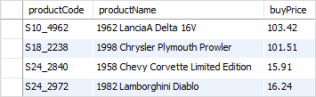

You can rewrite the query above using the less than (<), greater than (>), and the logical operator () like this:

SELECT

productCode,

productName,

buyPrice

FROM

products

WHERE

buyPrice < 20 OR buyPrice > 100;

### **2) Using MySQL BETWEEN operator with dates example**

See the following orders table:

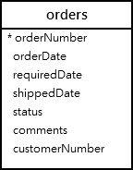

To check if a value is between a date range, you should explicitly cast the value to the DATE type.

For example, the following statement returns the orders with the required dates between 01/01/2003 to 01/31/2003:

SELECT

orderNumber,

requiredDate,

status

FROM

orders

WHERE

requireddate BETWEEN

CAST('2003-01-01' AS DATE) AND

CAST('2003-01-31' AS DATE);

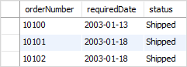

In this example, we use the CAST() to cast the literal string '2003-01-01' into a DATE value:

CAST('2003-01-01' AS DATE)

## **Summary**

* Use the MySQL BETWEEN operator to test if a value falls within a range of values.